Expt-3

# AIM:

Map Reduce program to process a weather dataset.

To implement MapReduce program to process a weather dataset.

# PROCEDURE:

## Create Weather Dataset:

nano weather_data.txt

## Example content:

20220101 30.5

20220102 29.8

## Mapper Program (mapper.py):

#!/usr/bin/env python3 import sys

for line in sys.stdin: line = line.strip()

month = line[4:6] # Extracting month temp = line[7:11] # Extracting temperature print(f'{month}\t{temp}')

## Reducer Program (reducer.py):

#!/usr/bin/env python3 import sys

current_month = None current_max_temp = -float('inf')

for line in sys.stdin: line = line.strip()

month, temp = line.split('\t')

try:

temp = float(temp) except ValueError:

continue

if current_month == month:

current_max_temp = max(current_max_temp, temp) else:

if current_month: print(f'{current_month}\t{current_max_temp}')

current_month = month current_max_temp = temp

if current_month == month: print(f'{current_month}\t{current_max_temp}')

## Run the Program:

hdfs dfs -mkdir /weatherdata

hdfs dfs -copyFromLocal weather_data.txt /weatherdata

hadoop jar $HADOOP_HOME/share/hadoop/tools/lib/hadoop-streaming-*.jar \

-input /weatherdata/weather_data.txt \

-output /weatherdata/output \

-mapper mapper.py \

-reducer reducer.py

## Check Output:

hdfs dfs -cat /weatherdata/output/part-00000

# OUTPUT:

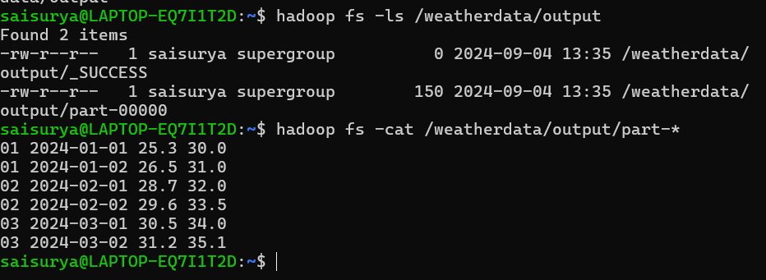

**RESULT:**

Thus, the program for weather dataset using Map Reduce has been executed successfully.